FULL WRAP matkamaja

WIFI password – Talinnnn
CAM – nimi – admin
password – Allan123
Ruuter – nimi – admin
password – admin1234
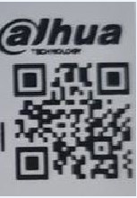

Android TV box Gmail account - wrapfull2021@gmail.com
Password - Talinnnn

