HONDA CR-V
2017~2021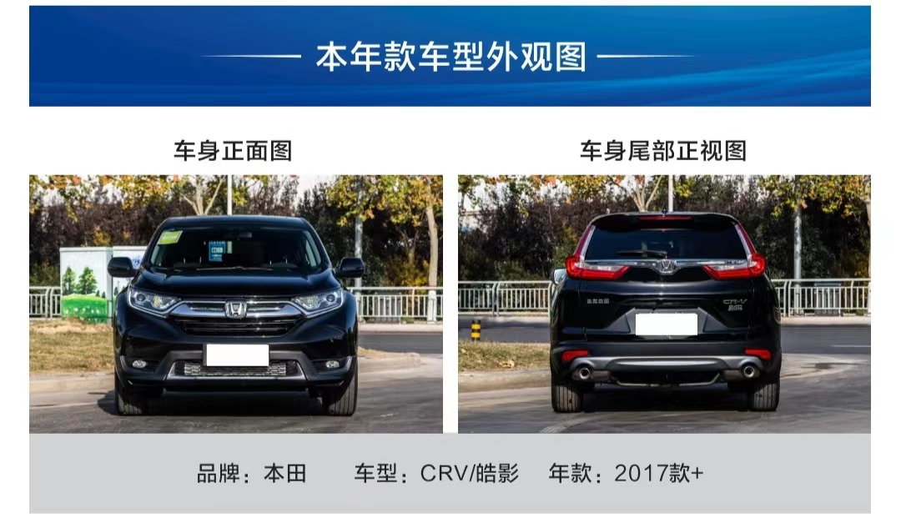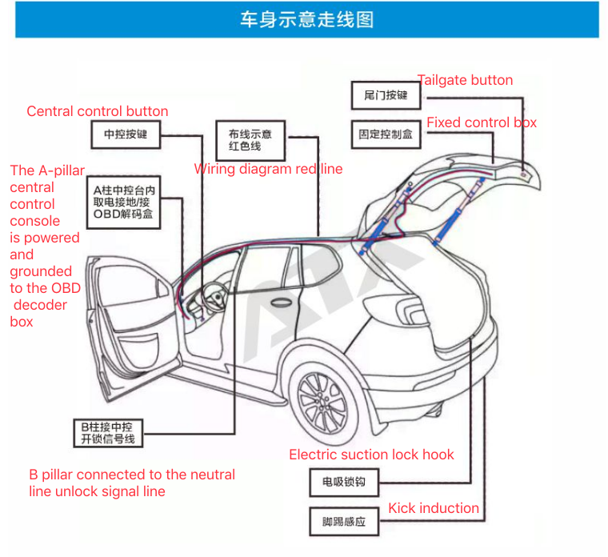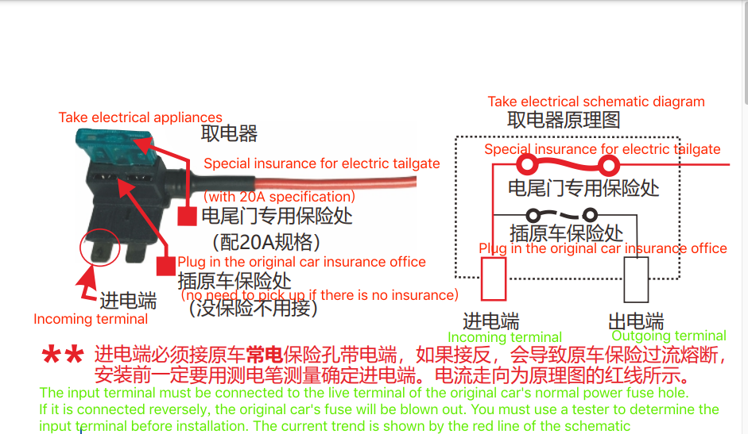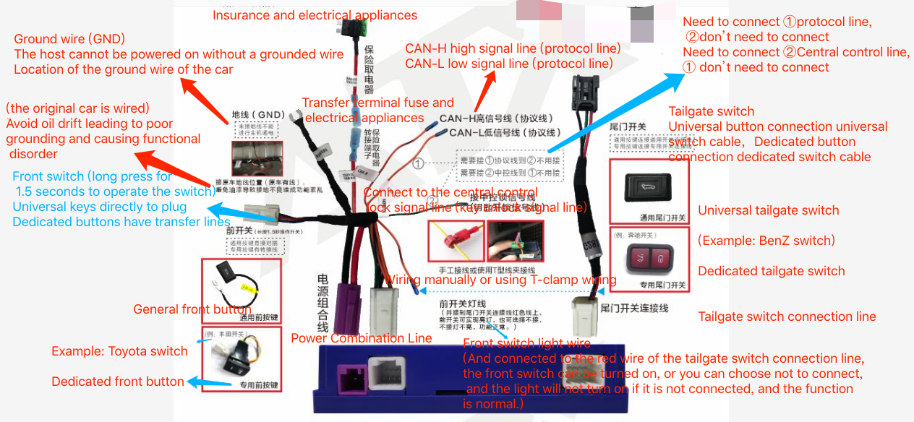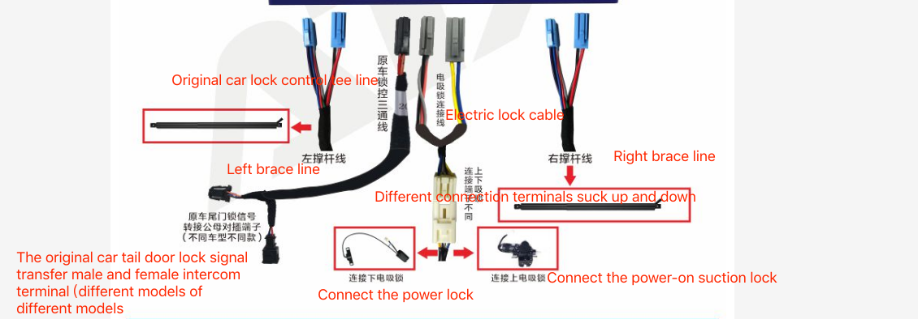
1. For safety and to ensure the normal use of the product, please leave it to the professional staff who sells this product to install it. Do not disassemble the machine without permission, as this may cause damage to the machine and accidents.
2. The first step before loading the vehicle is to first consult the owner of the rear door whether it has been modified or repaired, and inform the customer that during the installation process it is possible to drill and route the cable, start the engine, check whether the car instrument has a fault code display, and verify the door side switch in the car , The sunroof switch, the remote control key button is normal, check whether the inner and outer surfaces of the car are scratched, the size of the gap between the left and right sides of the original rear door and the flatness of the high ground, this is a key parameter for reference comparison after installing the electric tail door, if there is any abnormality Please inform customers in time.
3. Make sure that the car battery has enough power to ensure the normal operation of the electric tailgate.If the power is insufficient, please start the engine for a period of time to affect the normal operation of the electric tailgate and the start of the car.
4. Before disassembly, the installer should first remove the metal objects and other hard objects carried on his body to prevent damage to the car's interior during the disassembly.
5. During the installation process, pay attention to the use of masking paper and towels to protect the car interior from scratches. The removed car components should be put away. The debris left in the wiring and wiring should be handled in time, and should not be left in the car. Inside. The joint must be well green to prevent short
6.If you install a special bracket when installing the body bracket, please replace the special bracket. Pay attention to distinguish the direction.Do not install it backwards, otherwise it will cause the pole to fall or the tailgate will not be closed properly, or even scratch the original car's paint (refer to the installation process for details) ).
7. Make sure the direction and position before installing the brace bar to avoid damage caused by disassembly or loose deformation of the circlip. After installing the ball head, pay attention to press the circlip on the ball head into place, otherwise it will cause the rod to drop (it is best to use a point (Pull the brace outward to see if the brace is loose, if there is a loose phenomenon, the snap spring is not locked in place)
8. When taking power from the electrical appliance, be sure to take power from the high-current fuse of the fuse box B+ and do not affect other functions on the car. Pay attention to the position of the ground wire to ensure a good circuit (please follow our installation process)
9.When drilling holes on the brace connecting line, be sure to drill holes in accordance with the marking position of our drilling guide, and pull the car door down properly to ensure that the drill bit is perpendicular to the drilling position, causing the drill bit to pull and scrape other places. flower
10.When laying the CAN cable/power cable/front button cable/electric suction box connection cable, all the wires and plugs should be tied to the threader with the smallest area (the big plug is tied to the front, the small plug and the tied cable are at the back), Spray the table wax in the original car threading tube to facilitate threading (refer to the installation process guideline for the specific layout location)
11. Please do not plug or unplug the connected leads and accessories when it is turned on, so as not to damage the host or accessories during plugging and unplugging. The above content is subject to change without further notice, the final solution right belongs to the company。
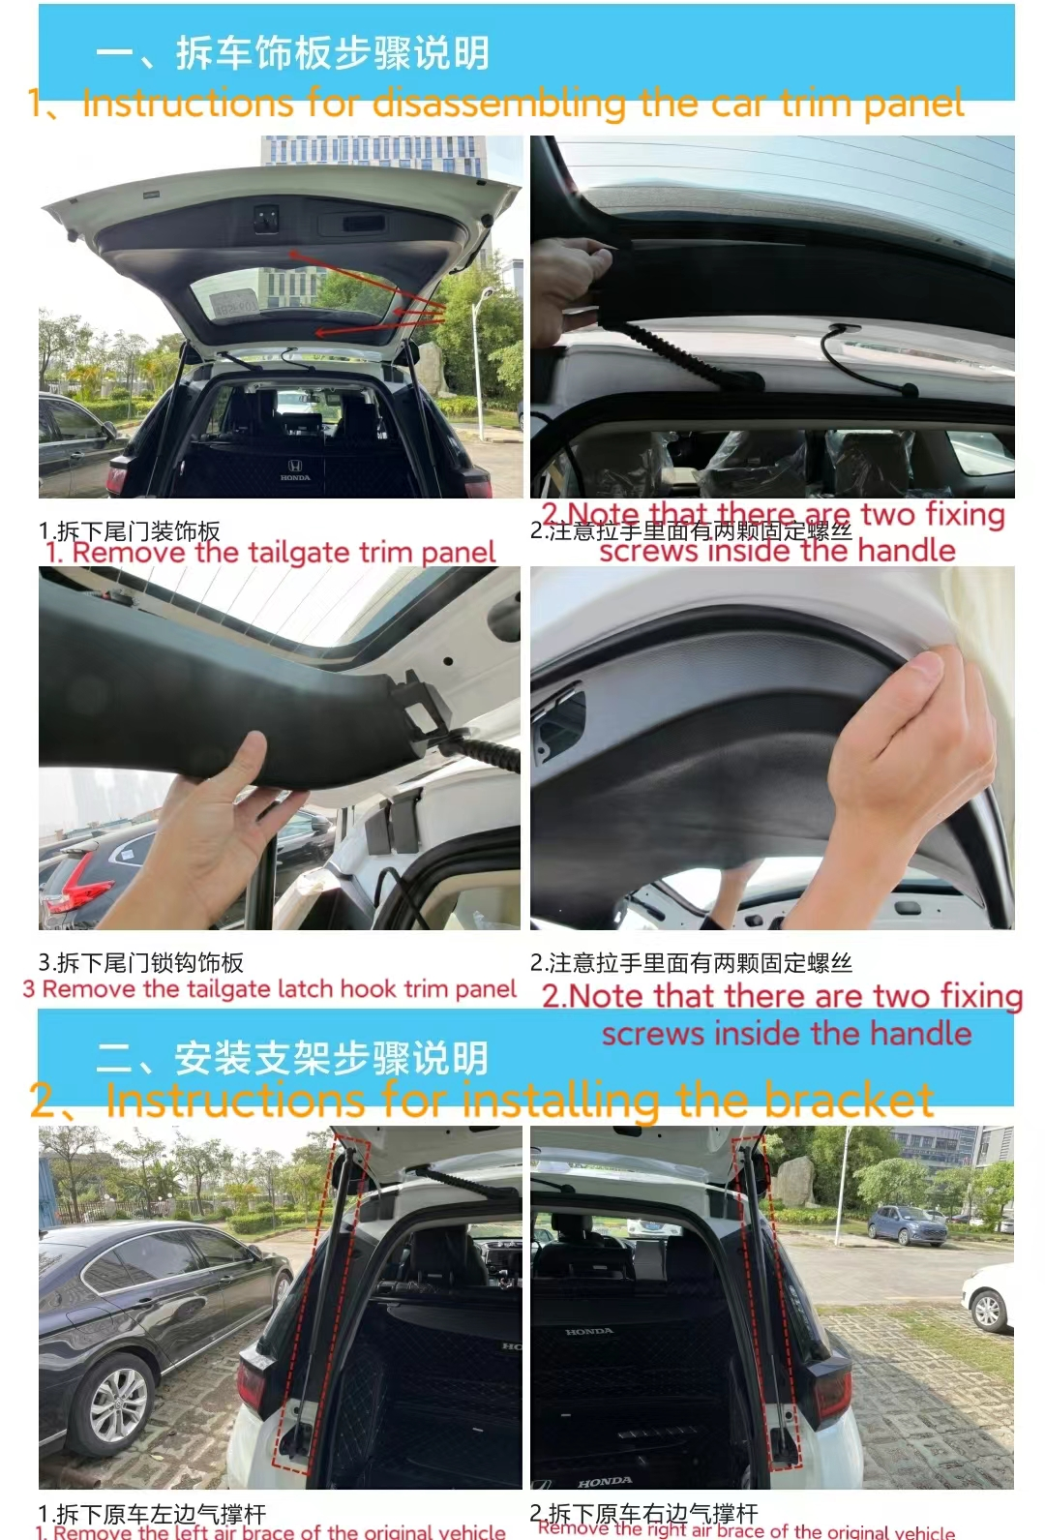
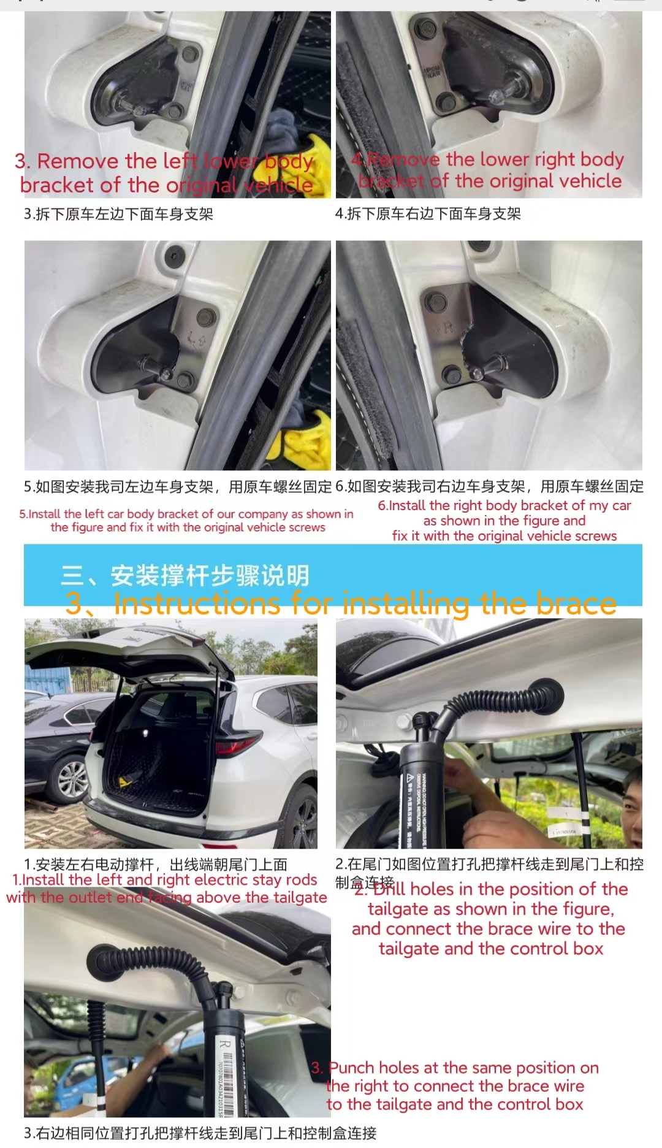
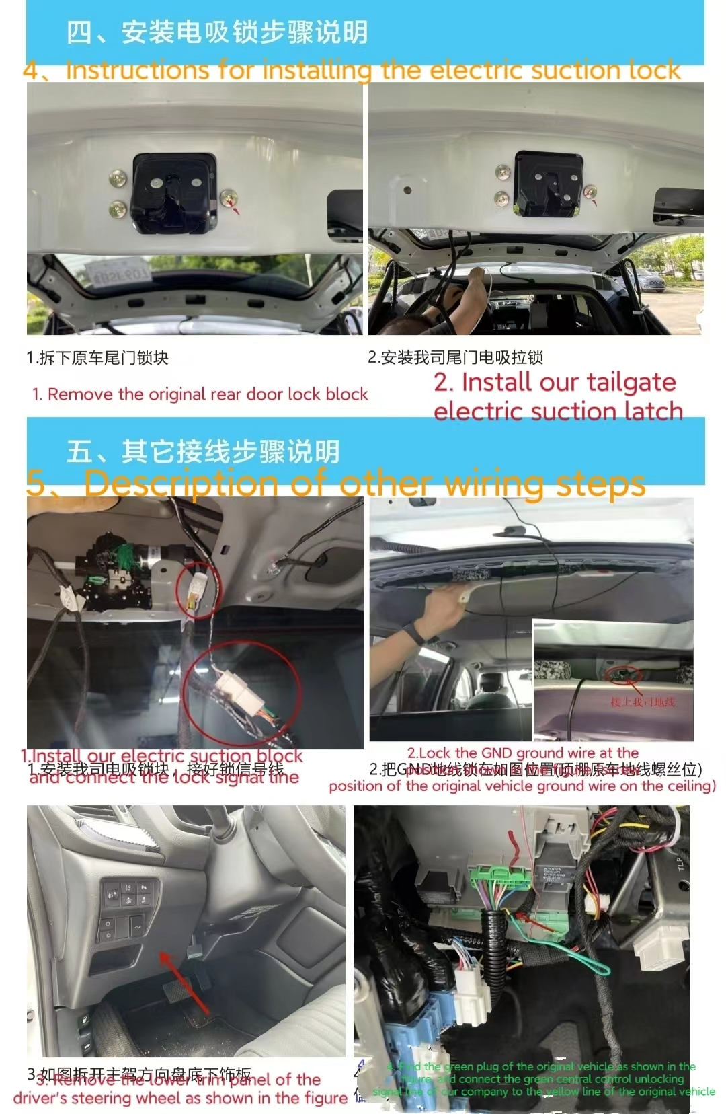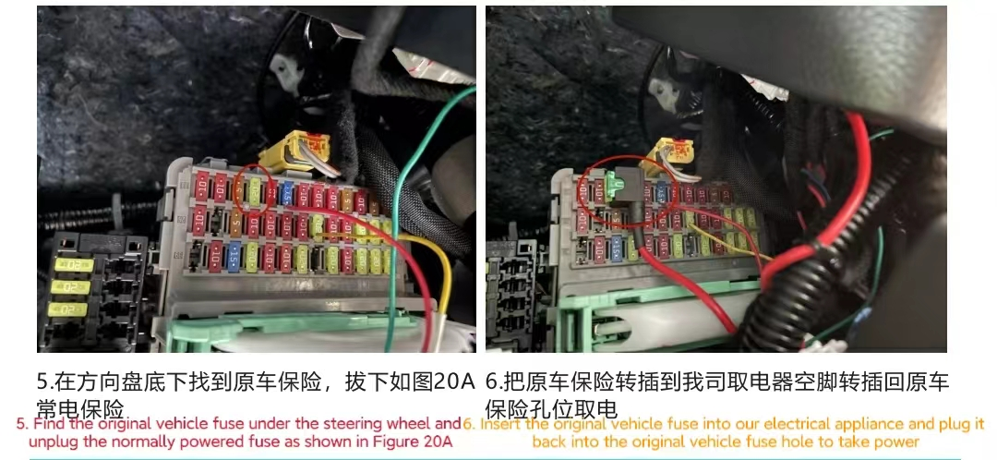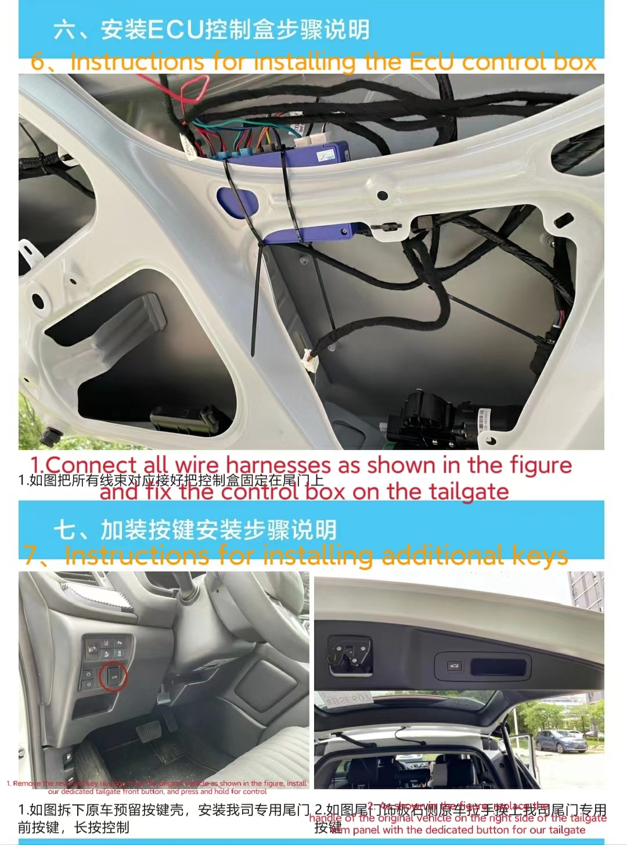
Original car
Key-Long press the tailgate button
Hand button-/
Button in front of the driver's seat-one click
Driving position unlock button (requires central control lock signal line) -/

Retrofit
Tailgate button-one click
Button in front of driving position-press for 1.2 seconds
Kick sensing (optional)-lift the foot in the sensing area for 1 second

