

AUDIO WARRANTY POLICY

EMEA Ver. B (02/2025)

WARRANTY STATEMENT

THE WARRANTIES AND REMEDIES CONTAINED HEREIN ARE EXCLUSIVE AND IN LIEU OF ALL OTHER WARRANTIES EXPRESS OR IMPLIED OR STATUTORY, INCLUDING ANY LIABILITY ARISING UNDER ANY WARRANTY OF MERCHANTABILITY OR FITNESS FOR A PARTICULAR PURPOSE, STATUTORY OR OTHERWISE. THIS WARRANTY GIVES THE OWNER SPECIFIC LEGAL RIGHTS, AND YOU MAY HAVE OTHER LEGAL RIGHTS, WHICH MAY VARY FROM STATE TO STATE (OR BY COUNTRY OR PROVINCE). GARMIN DOES NOT EXCLUDE, LIMIT OR SUSPEND OTHER LEGAL RIGHTS YOU MAY HAVE UNDER THE LAWS OF YOUR STATE (OR COUNTRY OR PROVINCE). FOR A FULL UNDERSTANDING OF YOUR RIGHTS, YOU SHOULD CONSULT THE LAWS OF YOUR STATE, COUNTRY OR PROVINCE.

IN NO EVENT SHALL GARMIN BE LIABLE FOR ANY INCIDENTAL, SPECIAL, INDIRECT OR CONSEQUENTIAL DAMAGES, WHETHER RESULTING FROM THE USE, MISUSE OR INABILITY TO USE THIS PRODUCT OR FROM
DEFECTS IN THIS PRODUCT. Some Countries and Provinces do not allow the exclusion on incidental or consequential damages, so the above limitation may not apply to customers in those areas.

Garmin retains the right to repair or replace the product or offer a full refund of the purchase price at its sole discretion. SUCH REMEDY SHALL BE THE CUSTOMER’S SOLE AND EXCLUSIVE REMEDY FOR ANY BREACH OF WARRANTY.
This Policy supplements and is in addition to the consumer limited warranty (the “Limited Warranty”). In the event of a conflict between the terms of this Policy and the Limited Warranty, these terms will govern, but solely with respect to marine products listed in Appendix 1: Marine Audio, Appendix 2: Car Audio, Appendix 3: Powersports Audio, and Appendix 4: Home Audio.

WARRANTY/PRODUCT REGISTRATION

Dealers/Original Equipment Manufacturers (OEM) are encouraged to register their customer’s installation at the dealer resource center or to encourage their customer to register their product within 30 days after the date of sale. Marine Customers can register their Garmin Fusion branded products using the Active Captain App.

Product registration cards are not included with some units. Under these circumstances, make sure to date your customer’s sales receipt as this is their proof of purchase, or you may register your customer’s installation at the DRC registration page.

When the dealer receives a Garmin/Fusion®/ JL Audio branded product for service, proof of warranty is required. It can be verified in one of three ways:
- The dealer can keep a record of customer names, serial numbers and purchase dates; or
- The customer can present his/her original sales receipt for proof of purchase; or
- The dealer can go to the Garmin dealer registration portal (DRC) at https://dealers.garmin.com/drc.

In addition, to qualify for onboard warranty for Garmin/Fusion/JL branded products, Garmin requires proof of authorized installation by a Garmin certified entity or an authorized Garmin OEM boat builder. Garmin certified entity is defined as an entity that has attended a Garmin certification training and holds a certificate from the National Marine Electronics Association (NMEA), MEI, AMEI or CMET certification or the American Boat and Yacht Council (ABYC) Electrical certification or the Mobile Electronics Certified Professional (MECP) / JL MAX Certification. Authorized OEM is defined by Garmin; please contact to confirm eligibility.

Note: Products not listed in the Appendices of this policy or an Appendix of another Warranty Policy of the Marine Warranty Policies are covered by the Garmin One-year Consumer Limited Warranty. For avoidance of doubt, this policy only applies to Garmin/Fusion®/ JL Audio branded Audio products listed in Appendix 1: Marine Audio, Appendix 2: Car Audio, Appendix 3: Powersports Audio, and Appendix 4: Home Audio.

GARMIN MARINE AUDIO WARRANTY
There are two types of warranties available to customers in this region:

Type 1: Standard Consumer Limited Warranty — Self-performed owner-installed equipment
Type 2: 2. Certified Onboard Limited Warranty – Approved Installations for products listed in Appendix 1: Audio, attached hereto.

Type 1: Standard Consumer Limited Warranty — Owner Installation

    - Fusion and JL branded products listed in Appendix 1: Marine Audio are warranted to be free from defects in material or workmanship for a period of three (3) years from the date the product was purchased by the first customer. Within this period, Garmin will, at its sole option, repair or replace any components that fail in normal use.

    - Garmin/Fusion/JL Audio Products not listed in Appendix 1: Marine Audio are covered by the Garmin One-year Consumer Limited Warranty.

    - Such repairs or replacements of products listed in Appendix 1: Marine Audio will be made at no charge to the customer for parts, provided that the customer shall be responsible for any transportation costs to Garmin.

    - Garmin will not pay for onboard labor or travel required for this standard limited warranty.

    - This standard limited warranty does not affect the customer’s statutory rights under applicable laws or the customer’s rights against the retailer arising from the sales/purchase contract. In the absence of any contrary applicable laws, this standard limited warranty will be the customer’s sole and exclusive remedy against Garmin, and neither Garmin nor its affiliated entities will be liable for any incidental or consequential damages for breach of any expressed or implied warranty.

Standard Limited Warranty Returns Procedure

    - Customers and dealers should first contact a Garmin/Fusion/JL Audio product support representative for technical assistance. After standard troubleshooting fault tests have been performed, a return material authorization (RMA) number will then be given. This RMA number is to be marked in plain view on the package being shipped to Garmin for the warranty service. This RMA number will act as a reference number for all parties involved. Technical assistance and request for an RMA can be made by visiting the Garmin Support Center.

For JL products please visit: The JL Audio Help Center

    - The returned product must be shipped (insured) to Garmin with proof of purchase and the RMA number marked in plain view on the package. The regional shipping address will be provided by Garmin at the time of RMA.

    - Customers may choose to hire a certified dealer to perform this return procedure at the customer’s expense.

Type 2: Certified Dealer Limited Warranty, including Parts and Onboard — Approved Dealer Installations

    - The The Onboard Warranty is applicable to specific Garmin Fusion/ JL Audio products only as listed in Appendix 1: Marine Audio, attached hereto, and only for Approved Installations which means installed by:

- A NMEA/ABYC/MECP installation shop with at least one certified member on staff,
- An approved Garmin service dealer,
- An approved Garmin OEM boat builder; or
- By a non-approved OEM boat builder that undertook the installation and had it approved and commissioned by an NMEA dealer or an approved Garmin service dealer.
    - The warranty period commences from the date the Garmin/Fusion/JL branded products were purchased by the first retail customer.

    - Customers shall contact Garmin or an authorized service dealer within 30 days of a Garmin/Fusion branded product failures for service. All customers and/or dealers are required to perform standard trouble-shooting methods before an actual Onboard Warranty situation shall exist. Customers and dealers can be assisted in doing this by contacting Garmin product support directly at (Inside UK) 08082380000 or (outside UK) +44 3708501242 or marinedts.europe@garmin.com.

    - Installations made by a third party that is not a Garmin and NMEA or ABYC certified entity, MAX or MECP certified entity is not approved by Garmin and will be classified as owner installations and will therefore be covered by the Type 1: Standard Consumer Limited Warranty described above or the Garmin One-year Consumer Limited Warranty.

    - Proof of Garmin onboard warranty coverage is required. Proof of warranty is composed of the following:

- Invoice with original date of device purchase, and
- Product serial number, and
- Proof of an authorized Garmin and NMEA or ABYC, MAX or MECP certified installation for Marine
    - The Garmin onboard warranty does not affect the customer’s statutory rights under applicable laws, nor the customer’s rights against the retailer arising from the sales/purchase contract. In the absence of any contrary applicable laws, this onboard warranty will be the customer’s sole and exclusive remedy against Garmin, and neither Garmin nor its affiliated entities will be liable for any incidental or consequential damages for breach of any expressed or implied warranty.

Onboard Warranty Procedure: Claim Form and Supporting Documentation

    - Customers should contact Garmin Europe or a Garmin and NMEA/ABYC/MAX/MECP certified entity within 30 days of a product failure for warranty service. All customers and/or Garmin and NMEA/ABYC/MAX/MECP certified are required to perform standard troubleshooting fault tests to determine whether onboard warranty service is appropriate. After standard troubleshooting fault tests have been performed, an RMA number will then be given. This RMA number is to be marked in plain view on the package being shipped to Garmin for the warranty service. This RMA number will act as a reference number for all parties involved. Technical assistance and request for an RMA can be made by visiting the Garmin Support Centre.

For JL products please visit: The JL Audio Help Center

    - Each onboard warranty service must be accompanied by a warranty claim form, which must be completed in full and is used to track the claim. It is to be quoted in any matters regarding the claim.

    - Failure to complete the form or missing or insufficient information will delay in processing the claim and may result in claim denial.

    - A completed service report (invoice/work order) must be attached to the warranty claim form. The service report should include service time, shop rate, fault symptoms, repair remedy and should include reason for additional labour/travel/mileage if approved by Garmin. All service reports must be completed in English.

    - Labour will be paid at the agreed rate within your territory for all warranty claims made in accordance with this warranty policy. The current maximum repair or replacement times are detailed in Appendix 1: Marine Audio, attached hereto. Variation from these amounts must be approved by the Garmin Europe Marine Warranty Administrator in this instance please state contact name in service report.

    - Details of travel time, stating location of boat, service agent who conducted the repair or replacement, and any documentary proof of travel payments should be supplied with the warranty claim or travel expenses will be rejected. Travel and mileage allowances will be in accordance with Appendix 1: Marine Audio.

    - If within a reasonable distance, Garmin expects the installing dealer to carry out the Onboard Warranty service. In other situations, it is expected that the nearest service agent to the vessel will carry out the onboard warranty service, therefore keeping costs of travel time and mileage to a minimum. Should the travel time and mileage exceed what is expected to be reasonable, prior authorization from Garmin is required.

    - No Sea Trial Allowance

OTHER AUDIO POLICIES:

GARMIN CAR AUDIO WARRANTY

    - Garmin / JL Audio warrants Car Audio products to be free of defects in materials and workmanship from the original date of purchase for these periods:

One (1) year from the original date of purchase: Car Speakers and Subwoofers, No labor or travel
Two (2) years from the original date of purchase: Car Amplifiers, Electronics, Enclosed Subwoofers, Stealthbox and Connection Products, No labor or travel

    - XDM and MX amplifiers carry a 3 year parts only warranty since they are Marine products.

Note: The Car Amplifier Warranty Period is extended to three (3) years when accompanied with the purchase of a qualifying JL Audio Amplifier Power Connection System and with installation by an authorized JL Audio dealer.

GARMIN POWERSPORTS AUDIO WARRANTY

Garmin / JL Audio warrants Powersport Audio products to be free of defects in materials and workmanship for a period of three (3) years from the original date of purchase. No labor or travel

GARMIN HOME AUDIO WARRANTY

    - Garmin / JL Audio warrants Home Audio products to be free of defects in materials and workmanship from the original date of purchase for these periods:

Three (3) years from the original date of purchase: Subwoofers and Electronics, No labor or travel
Five (5) years from the original date of purchase: Pavilion Outdoor Speakers, No labor or travel

Warranty Exclusions – Applies to all Garmin/Fusion/JL branded products

    - In addition to the limitations above, the warranty exclusions set forth below shall apply to the Standard Consumer Limited Warranty, Certified Dealer Limited Warranty and the Authorized OEM Limited Warranty.

    - Installation not in accordance with the installation guidelines provided in the Garmin user/install manual will invalidate the warranty.

    - The warranty policy does not cover product failures due to shipping damage, accident, abuse or misuse, improper storage, alteration or unauthorized repair, corrosion, products on which the serial number has been tampered with, power spikes, vandalism, water ingress, submersion, or other acts of God (force majeure) or weather phenomena such as lightning, flash floods, spills of food or liquids, maladjustment of customer controls, etc.

    - The warranty policy does not apply if Garmin was not notified by the consumer of the alleged defect or malfunction of the product during the applicable limited warranty period.

    - The warranty policy does not apply if the product was used with or connected to an accessory not supplied by Garmin or fit for use with Garmin branded products or used in a manner other than its intended use.

    - Garmin assumes no responsibility for damage incurred during installation.

    - The Garmin onboard warranty does not extend to self-performed owner-installed equipment or installations.

    - Digital switching systems are extremely flexible and highly configurable. As such, Garmin does not, and cannot, accept responsibility for providing guidelines for every circumstance and eventuality that may be encountered when designing and installing a digital switching system.

    - The warranty policy does not cover incorrectly specified product, incorrectly specified transducers, incorrect transducer installation, transducer aeration problems, RF interference installation problems, existing onboard electrical systems noise, stray voltages, chart cartography errors, units subjected to or connected to the incorrect voltage supply level or voltage type.

    - The warranty policy does not cover LCD displays that exhibit faulty pixels that are within technical specifications as determined by Garmin or the Garmin approved LCD supplier.

    - The warranty policy does not cover luxury software updates, system checkouts or calibrations unless these aforementioned activities are done in accordance with the user/installation manual of the product that is being repaired/serviced.

    - The warranty policy does not cover products for which a suitable proof of purchase showing date, dealer/retailer, serial number or installation invoice (if required) cannot be demonstrated at the time of the request for warranty service.

    - The warranty policy does not cover damage or costs resulting from the connection of third-party products.

    - The warranty policy does not cover freight costs associated with the return of defective equipment to Garmin nor is such freight payable by Garmin.

    - The warranty policy does not cover water intrusion caused by high-pressure water sprayers or damage to products caused by harsh chemicals.

    - The warranty policy does not cover costs associated with modified or painted products outside of manufacture specifications.

    - The warranty policy does not cover normal wear and tear or misuse, or cosmetic damage, such as scratches, nicks and dents.

    - The warranty policy does not cover damage to a product that has been connected to power and/or data cables that are not supplied by Garmin or damage to a product that has been connected to cables that are not certified by Underwriters Laboratories (UL) and are not labeled as Limited Power Source (LPS).

    - The warranty policy does not cover costs associated with or related to normal maintenance or replacement of parts or accessories that are not defined as a manufacture defect.

    - The warranty policy does not cover costs associated with or related to the removal and replacement of non Garmin products to gain access to Garmin products requiring replacement.

    - Product recalls: In the event Garmin chooses to recall a product from the field, we reserve the right to establish a fair rate (time, travel and hourly rate) for removal and replacement of such product based on a case-by-case situation.

    - Garmin reserves the right to refuse any warranty service claim it deems unfair or nonconforming to the policies and procedures set forth in this warranty document. In addition, Garmin reserves the right to refuse to pay warranty labor reimbursement to any service dealer it finds not performing quality work or manipulating this warranty policy in a way that is not in the interest of Garmin or the end user.

Product Returns

    - Any return of defective product must have an RMA number issued in advance.

    - The RMA is valid for 45 days from the date of issuance. Units must be returned to Garmin within this period; otherwise, the RMA may be canceled.

    - Unmarked boxes or returns without RMA numbers will be returned to sender.

    - Freight costs: Inbound delivery to Garmin is the responsibility of the Garmin and NMEA, ABYC, MAX, or MECP certified installation entity, OEM, dealer or the customer. Standard ground outbound shipping freight cost will be paid by Garmin. Overnight or second-day express delivery freight service is available at an additional cost, paid by the requester.

Appendix 1: Marine Audio

EMEA Rev. Ver. B (02/2025)
Owner Installed and Garmin and NMEA or ABYC and OEM / MAX / MECP Certified Installed Products
Three-year Warranty and Onboard Applies to the Following Specific Products
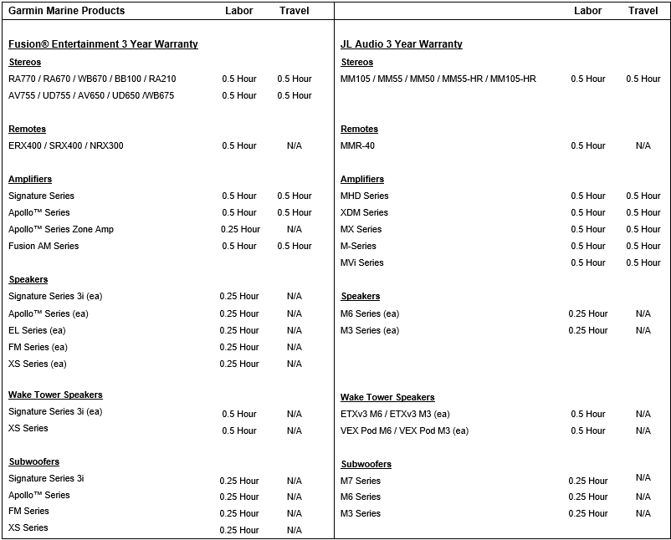

Notes:
- With the exception of Products subject to Type 1: Standard Marine Consumer Limited Warranty — Owner Installation, the Products listed in Appendix 1: Marine Audio must be installed by a Garmin and NMEA or ABYC certified entity or an authorized OEM boat builder for eligibility.
- The vessel hull number is required on the claim form for validation.
Mileage allowance and rates (where applicable above)
Maximum travel allowance prior to authorisation is 80 kilometers round trip

The above are the maximum allowances. The service report should reflect the amount of time claimed. Warranty service requiring extended time or expense must have prior authorization from the Garmin Europe Marine Warranty Administrator.
If within a reasonable distance, Garmin expects the installing dealer to carry out the Onboard Warranty service. In other situations, it is expected that the nearest service agent to the vessel will carry out the onboard warranty service, therefore keeping costs of travel time and mileage to a minimum. Should the travel time and mileage exceed what is expected to be reasonable prior authorisation from Garmin is required.

Appendix 2: Car Audio

EMEA Rev. Ver. B (02/2025)
Two-year Warranty for Parts Only Applies to the Following Specific Products:

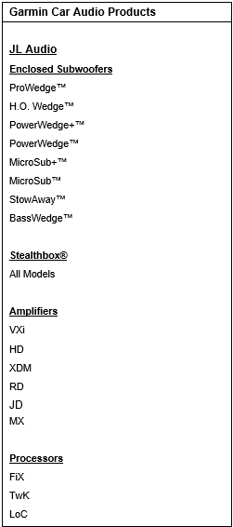

Note:
- Any products not listed above are covered by the One-Year Garmin Standard Consumer Limited Warranty
- There is no labor reimbursement for Car Audio Products
- XDM and MX amplifiers carry a 3 year parts only warranty since they are Marine products.

Appendix 3: Powersports Audio

EMEA Rev. Ver. B (02/2025)
Three-year (3) Warranty for Parts Only Applies to the Following Specific Products:

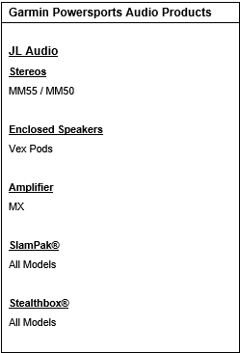

Note:
- Any products not listed above are covered by the One-Year Garmin Standard Consumer Limited Warranty
- There is no labor reimbursement for Powersports Audio Products

Appendix 4: Home Audio

EMEA Rev. Ver. B (02/2025)
Three-year (3) Warranty for Parts Only Applies to the Following Specific Products:

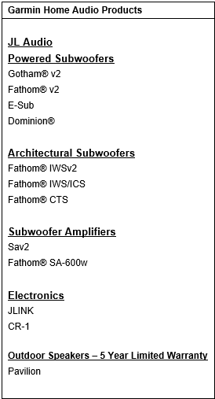
Note:
- Any products not listed above are covered by the One-Year Garmin Standard Consumer Limited Warranty
- There is no labor reimbursement for Home Audio Products
- Only the Pavilion Outdoor speakers are eligible for a (5) Five Year Warranty

