 |  |  | FITTING  INSTRUCTION | Rev. 0
Can Bus Diagram:  Bmw Serie 4 (G23) 2021 |  |  | 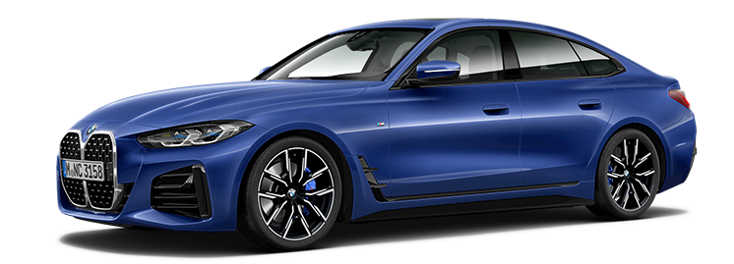
DIP SWITCH SELECTION & SOFTWARE
from CARLIST 33 and next | Remote control and keyless system | 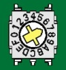7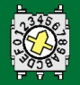5
Electrical connection between alarm and vehicle
Function | Alarm wire | Position and connection on vehicle
Power Supply  Pictures 1 - 2 | Red | Connect to the RED/WHITE wire pos.33 of the 54 pins BLACK connector marked 3B linked to the central unit behind the kickwell on the passenger side.
Power Supply  Pictures 1 - 2 | Black | Connect directly to the original ground node behind the kickwell on the passenger side.
Enabling CAN BUS  Pictures 1 - 3 | White/Green  CAN BUS H | Connect to the YELLOW/GREEN wire pos. 50, |  | of the 54 pins BLACK connector marked 8B linked to the central unit behind the kickwell on the passenger side.
Enabling CAN BUS  Pictures 1 - 3 | White/Brown  CAN BUS L | Connect to the BLUE or YELLOW/BLACK wire pos. 49,
Hazard  Picture 1 - 4 | Yellow/Green  (Hazard) | Connect to the ORANGE wire pos.31 of the 54 puins WHITE connector marked 7B linked to the central unit behind the kickwell on the passenger side.
Horn  Pictures 1 - 5 | White/Red | Connect to the RED/BROWN wire pos.3 of the 54 pins BLACK connector marked 2B linked to the central unit behind the kickwell on the passenger side.
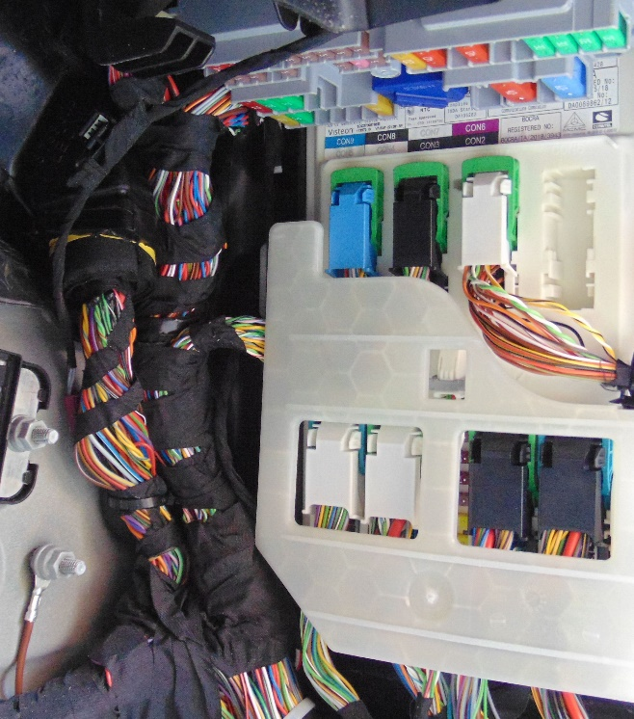  Pic.1  Hazard  + 30  Clacson  GND |  |  | Pic.2  + 30 |  | Pic.3  CAN BUS
 |  |  | Pic. 4  HAZARD |  | 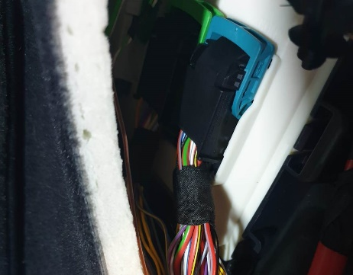  Pic.5  HORN
Additional connection
Engine Block  Max 10A | Green wires | Electric Block: cut the GREEN/WHITE wire pos. 2 of the 54 pins BLACK connector marked 3B linked to the central unit behind the kickwell on the passenger side.

