 |  |  | FITTING  INSTRUCTION | Rev. 1
Can Bus:  Bmw 5 series (G30) 2017 |  |  | 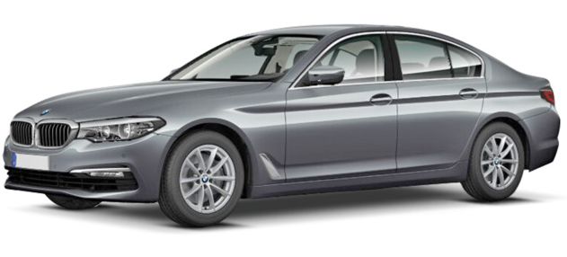
DIP SWITCHES SELECTION & SOFTWARE
From LIST 31 and forward | Remote control  &  Keyless | 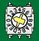7 5

ELECTRICAL CONNECTIONS BETWEEN ALARM AND VEHICLE
Function | Alarm wire | Position and vehicle connection
Power supplier  Pic. 1 and 3 | Red | Connect to the RED wire pos 33 of the 54-pin ways BLACK connector marked “CON 3” located on the main unit placed under the kickwell passenger’s side.
Power supplier  Pic. 1 and 3 | Black | Connect directly to the original ground node placed behind the kickwell passenger’s side.
CAN BUS H  Pic. 2 and 3 | White/Green | Connect to the YELLOW/RED wire pos. 50, |  | of the 54-pin ways BLACK connector marked “CON 8” located on the main unit placed under the kickwell passenger’s side.
CAN BUS L  Pic. 2 and 3 | White/Brown | Connect to the YELLOW/BROWN wire pos. 49,
Blinkers  Fig. 3 | Yellow/Green  (Hazard) | Connect to the BROWN/BLUE wire pos.31 of the 54-pin ways WHITE connector marked “CON 7” located on the main unit placed under the kickwell passenger’s side.
HORN command | White/Red | Connect to the RED/BNROWN pos.3 of the BLACK “CON2” connector, linked to the WHITE central unit, located on the main unit placed under the kickwell passenger’s side.
 |  |  |  |  | 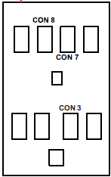

Optional connection:
Central door lock | PURPLE  (Locking) | Info not available yet.
Central door lock | YELLOW/BLUE  (Unlocking) | Info not available yet.
Engine kill block  Max 10A | GREEN wires | Engine cut off: cut the ORANGE wire pos. 2 of the 54-pins BLACK connector marked “CON 3” located on the main unit placed under the kickwell passenger’s side.
COMFORT command | BROWN/BLACK | Info not available yet.

