 |  |  | FITTING  INSTRUCTION | Rev. 0
Can Bus diagram:  BMW X6 (G06) 2020 |  |  | 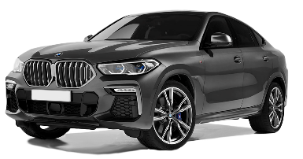
DIP SWITCHES SELECTION & SOFTWARE
From CARLIST31  and next | Remote control &  Keyless | 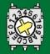7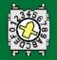 5

ELECTRICAL CONNECTIONS BETWEEN ALARM AND VEHICLE
Function | Alarm wire | Position and vehicle connection
Power supplier  Pic. 1, 2, and 3 | Red | Connect to the RED/BLUE wire pos. 33 of the 54-pin ways BLACK connector marked “CON 3” located on the main unit placed under the kickwell passenger’s side.
Power supplier  Pic. 1, 2, and 3 | Black | Connect directly to the original ground node placed behind the kickwell passenger’s side.
Enabling CAN BUS  Pic. 1 and 4 | White/Green  CAN BUS H | Connect to the YELLOW/WHITE wire pos. 48, |  | of the 54-pin ways BLACK connector marked “CON 8” located on the main unit placed under the kick wall passenger’s side.
Enabling CAN BUS  Pic. 1 and 4 | White/Brown  CAN BUS L | Connect to the YELLOW/BLACK wire pos. 47,
Alternative enabling  CAN BUS | White/Green  CAN BUS H | Connect to the YELLOW/WHITE wire pos. 36, |  | of the 54-pin ways WHITE connector marked “CON 7” located on the main unit placed under the kick wall passenger’s side.
Alternative enabling  CAN BUS | White/Brown  CAN BUS L | Connect to the YELLOW/BLACK wire pos. 35,
Hazard  Pic. 1 and 5 | Yellow/Green | Connect to the WHITE/GREEN wire pos. 31 of the 54-pin ways WHITE connector marked “CON 7” located on the main unit placed under the kick wall passenger’s side.
HORN | White/Red | Connect to the RED/BROWN pos. 3 of the BLACK “CON2” connector, linked to the WHITE central unit, located on the main unit placed under the kick wall passenger’s side.
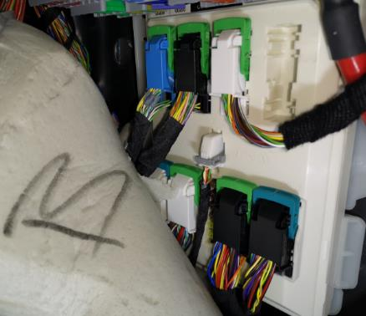  Horn  CAN BUS  Foto 1  +Power  Central unit  Hazard |  |  | 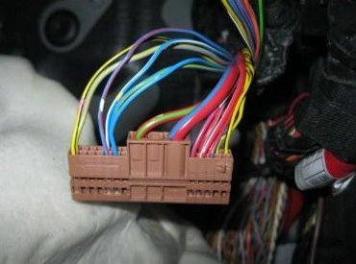 |  | 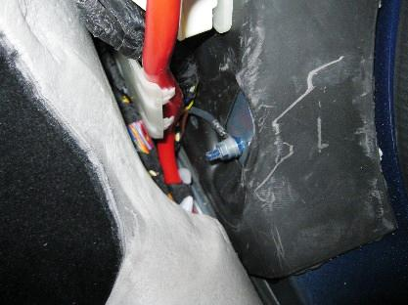
 |  |  | 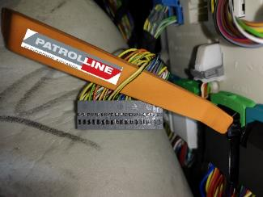  Pic. 4  CAN BUS |  | 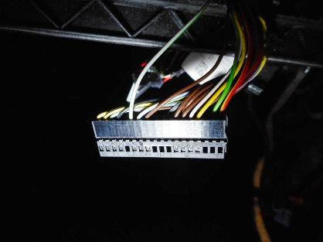

Optional connection:
Engine Block  Max 10A | Green wires | Starting Block: Cut the ORANGE wire pos.2 of the 54 pins BLACK connector marked “CON3”, linked to the central unit, fixed behind the kickwell on the passenger side.
Engine Block  Max 10A | Green wires | Starter motor lock (use an additional relay 30A): Cut the BLACK wire pos.1 of the 42 pins BLACK connector marked “CON2” linked to the WHITE central unit, fixed behind the kickwell on the passenger side.

