 |  |  | FITTING  INSTRUCTION | Rev.0
Can Bus Diagram:  Dacia Dokker 20122021 |  |  | 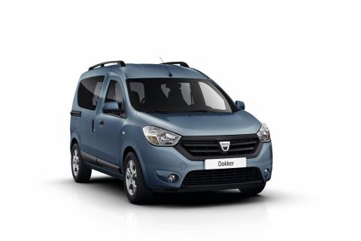
DIP SWITCH O SOFTWARE
da CARLIST29  e successive | Versione con radiocomandi | 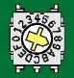9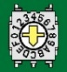C

ELECTRICAL CONNECTION BETWEEN ALARM AND VEHICLE
Function | Alarm colour wire |  | Position and vehicle connection
Power Supply  See picure 1A/1B | Red wire |  | Connect to the RED wire pos. 12 of the 12-pin ways BROWN connector linked to the BLACK main unit under the dashboard driver’s side.
Power Supply  See picure 1A/1B | Black wire |  | Connect to the BLACK wire pos. 7 of the 12-pin ways BROWN connector connected to the BLACK main unit under the dashboard driver’s side.
Enabling CAN BUS | White/Green  CAN BUS H |  | Connect to the wire in pos.6 of the 16-pin way OBD connector located under the dashboard driver’s side.
Enabling CAN BUS | White/Brown  CAN BUS L |  | Connect to the wire in pos.14 of the 16-pin way OBD connector located under the dashboard driver’s side.
Indicator light  see picture 2 | Yellow wires |  | Connect to the WHITE wire pos. 5 and BROWN wire pos. 12 of the 12-pin ways WHITE connector linked to the BLACK main unit under the dashboard driver’s side.
Horn command | White/Red: |  | info not available yet
ECU view  Picture 1A |  | + 30  GND  Picture 1B  + 30 |  | BLINKERS  Picture 2 | Picture 3
Optional connection
Central door looking | PURPLE unlock | NEGATIVE COMMAND ON UNIQUE WIRE.  Connect the opening and closure alarm command to the GREEN wire pos. 31 of the 40-pin ways BLACK connector linked to the linked to the BLACK main unit under the dashboard driver’s side.
Central door looking | YELLOW/BLUE lock
Engine Block  Max 10A  See picture 3 | Green wires: | STARTING ENGINE: cut the PINK wire pos. 3 of the 4-pin ways RED/BLACK connector connected directly to the mechanical key starting block.  Check carefully the Ampere consumption while the starting command. Add a supplementary relays in order to avoid alarm mistakes.  FUEL PUMP: info not available yet.
Comfort command  Max 100 mA | Brown/Black: | Original comfort function not present. In order to rolling up the windows of the vehicle is need to add a supplementary module marked Hps44

