 |  |  | FITTING INSTRUCTIONS | Rev. 0
Can Bus:  Dacia Duster 2017 |  |  | 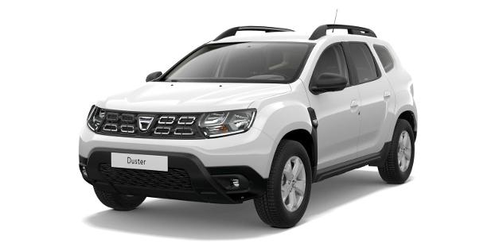
DIP SWITCHES OR SOFTWARE SELECTION
From CARLIST29 and next | Remote controlled version | 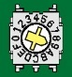9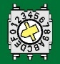F
From CARLIST29 and next | Keyless version and all version from 2021 | 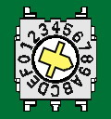9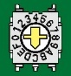C
CONNECTIONS BETWEEN ALARM AND VEHICLE
Function | Alarm wire | Position and connection on the vehicle
Power  Picture 1 | Red | Connect to RED wire pos.10 |  | 12 pins WHITE connector marked P1 linked to the BCM central unit behind the fuse box under the dashboard on the driver side.
Power  Picture 1 | Black | Connect to BLACK wire pos.8
Power Blinker  Picture 1 | Yellow - Yellow  (power blinker) | Connect to LIGHT BROWN wire pos.5 and to BLACK/WHITE wire pos.12
Enabling CAN BUS  Picture 2 | White/Green  CAN BUS H | Connect to LIGHT BROWN wire pos.4 |  | 40 pins BLACK connector marked S1, linked to the BCM central unit behind the fuse box under the dashboard on the driver side.
Enabling CAN BUS  Picture 2 | White/Brown  CAN BUS L | Connect to WHITE wire pos.3
Horn | White/Red | Connect to the WHITE wire pos. 14 in the GEY 16 pin connector, behind the blinker lever.
Optional connections:
Central door locking | Purple wire unlock | Only one wire NEGATIVE command.  Connect the alarm lock and unlock wire to the BROWN wire pos.31 of the 40 pins BLACK connector marked S1, linked to the BCM central unit behind the fuse box under the dashboard on the driver side.
Central door locking | Blue/Yellow wire lock
Engine Block  MAX 10A | Green wires | Starter Kill: Cut the WHITE wire pos.3 of the 6 pins BLACK connector directly linked to the Key block.  Engine block: Cut the YELLOW wire sez.0,5mmq linked to the 5A fuse N°19 into the fuse box, under the dashboard on the driver side.
Comfort command  MAX 100mA | Brown/Black | Information not available.

