 |  |  | FITTING  INSTRUCTION | Rev. 2
Can Bus Diagram:  Opel Meriva 2014 2018 |  |  | 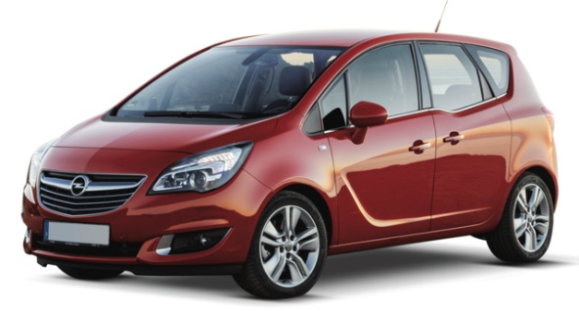
DIP SWITCH SELECTION AND SOFTWARE
From Carlist29  and higher | Remote control version | 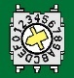 F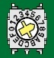 7

CONNECTION BETWEEN ALARM AND VEHICLE
Function | Alarm wire | Position and vehicle connection
Power supply | Red | Connect to the RED/GREEN wire of the 1-pins BLACK connector located in front of the fuse box under dashboard driver side. See pic. 1.
Power supply | Black | Connect to the original ground node placed behind the kick wall passenger side.
CAN BUS L | White/Brown | Do not connect
CAN BUS H | White/Green | Connect to the GREEN wire pos. 16, | of the 60-pins BROWN connector located on the rear to the main unit present under the dashboard driver’s side. See pic. 2
Blinker | Yellow/Green  (Hazard) | Connect to the BROWN/YELLOW wire pos. 57,
Horn | White/Red | Negative command: set the alarm output according.  Connect to the BROWN/BLACK pos. 18 of the 60-pins BLACK connector inserted in front of the fuse box at the left, under dashboard driver side. See pic. 1.
Power  Horn and  doors  Pic. 1 |  |  | CAN BUS H  and Hazard  Pic. 2  Foto 2  CAN BUS H  e Hazard

Attention: this vehicle is equipped with an energy saving system that is activated as soon as the vehicle is locked by its own remote control.
CAN BUS network isn’t so able to wake up soon, so, to disarm the alarm, keep remote control unlocking button pressed for two second at least or press it twice.

Attention: if the rear doors or trunk opening doesn’t wake up the BUS (doesn’t trig an alarm cycle), use the following doors/trunk connections:
Doors  and  Trunk | Blue  (disjunct the line by diodes) | Connect to the ORANGE/PURPLE pos. 6 – door front right,  Connect to the ORANGE/WHITE pos. 11 – door rear left,  Connect to the ORANGE/GREEN pos. 10 – door rear right,  Connect to the BLUE/YELLOW pos. 42 – trunk, | in the 60-pins BLACK connector inserted in front to the left of the fuse box in the driver’s side. See photo 3.  Attention: disjunct the line by diodes.

OPTIONAL CONNECTIONS
Central door locking | Purple (opening) | Negative command, connect to the WHITE wire pos. B1 | of the 6-pins BLACK connector behind the locking/unlocking pushbutton in the centre of the dashboard.
Central door locking | Yellow/Blue (closure) | Negative command, connect to the ORANGE wire pos. A3
Engine Kill  Max 10A | Green wires | Starting kill (use an external 30A relays): cut the YELLOW/PURPLE wire pos. 6 of the 6-pins WHITE connector connected directly to the mechanical key block.  Fuel Pump (use an external 30A relays): cut the GREY wire present under the kick wall driver’s side.
REV. 2: aggiornamento informazioni sullo sleep mode della vettura

