 | FITTING  INSTRUCTIONS | Rev. 2
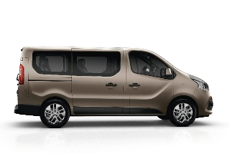
Can Bus diagram:
Renault Trafic III 2014 2021

DIP SWITCH or SOFTWARE SELECTION
Use upgrade from Carlist 29 forward | 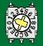 9 C
Use upgrade from Carlist 31 forward x HPS 846 if remote start engine function is required | 9 F

ELECTRICAL CONNECTIONS BETWEEN ALARM AND VEHICLE
Power supply  See picture 1A/1B | Red Wire: | Connect to the RED wire pos. 10 in the white 12 poles connector named P1 on the BCM under the dashboard driver side.
Power supply  See picture 1A/1B | Black Wire: | Connect to the original ground point on the driver side.
Can Bus H  See picture 2 | White/Green Wire | Connect to the PINK or BEIGE wire pos. 24 in the Black 40 poles connector named S1 on the BCM unit under the dashboard driver side.
Can Bus L  See picture 2 | White/Brown Wire: | Connect to the GREY or BLUE wire pos. 23 in the Black 40 poles connector named S1 on the BCM unit under the dashboard driver side.
Blinkers  See picture 3 | Yellow Wires: | Connect to the BROWN wire pos. 5 and GREEN wire pos. 12 in the white 12 poles connector named P1 on the BCM under the dashboard driver side.
Horn Command | White/Red Wire: | Information not available.
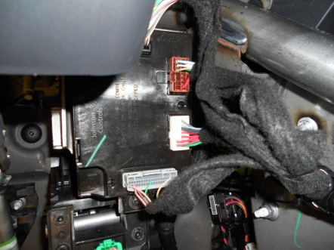
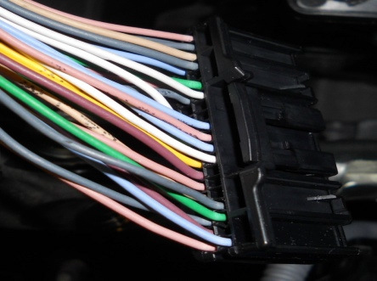
Optional Connections
Central door locking | Purple wire - unlock | CENTRAL DOOR LOCKING (Only for remote controlled alarm)  Negative command type. Connect both alarm wires (lock and unlock) directly to the WHITE pos. 31 in the black connector 40 poles named S1 on the BCM unit under the dashboard driver side.
Central door locking | Blue/Yellow wire - lock
Engine Stop (10A) | Green wires: | STARTER MOTOR: Cut the BROWN wire pos. 3 in the 6 pins BLACK/RED connector linked directly to the key block.  FUEL PUMP (diesel vehicles): Cut the YELLOW wire connected behind the fuse box near the fuse n°26 of 5A.
Comfort command | Brown wire: | The automatically windows locking is possible only through the original remote control command.

