 |  |  | FITTING  INSTRUCITONS | Rev. 0
Can Bus Diagram:  Suzuki Swace 2020 |  |  | 
DIP SWITCHES SELECTION AND SOFTWARE
From CARLIST29  and next | Remote control and Keyless version | 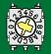24
ELECTRICAL CONNECTIONS BETWEEN ALARM AND VEHICLE
Function | Alarm function | Position of connection on the vehicle
Power supply | Red | Connect to the WHITE wire 10mm of the 1 pin WHITE connector on the front of the BCM central unit, fixed under the dashboard on the driver side. Or connect to the GREEN wire pos.16 of the 16 pins OBD connector, under the dashboard of the driver side.
Power supply | Black | Connect to the original ground node of the vehicle, under the kickwell of the driver side.
Enabling CAN BUS  See picture | White/Green  CAN BUS H | Connect to the BLUE wire pos.9 | 38 pins WHITE connector directly linked behind the instruments panel.
Enabling CAN BUS  See picture | White/Brown  CAN BUS L | Connect to the WHITE pos.25
Alternative 1 | White/Green | Connect to the BLACK wire | 20 pins WHITE connector fixed behind the perforated metallic plate, under the dashboard, behind the steering wheel.
Alternative 1 | White/Brown | Connect to the WHITE wire
Alternative 2 | White/Green | Connect to the GREEN wire pos.32 | 40 pins GREY connector, directly linked to the instruments panel.
Alternative 2 | White/Brown | Connect to the WHITE wire pos.31
CLACSON | White/Red | Info not available at the moment
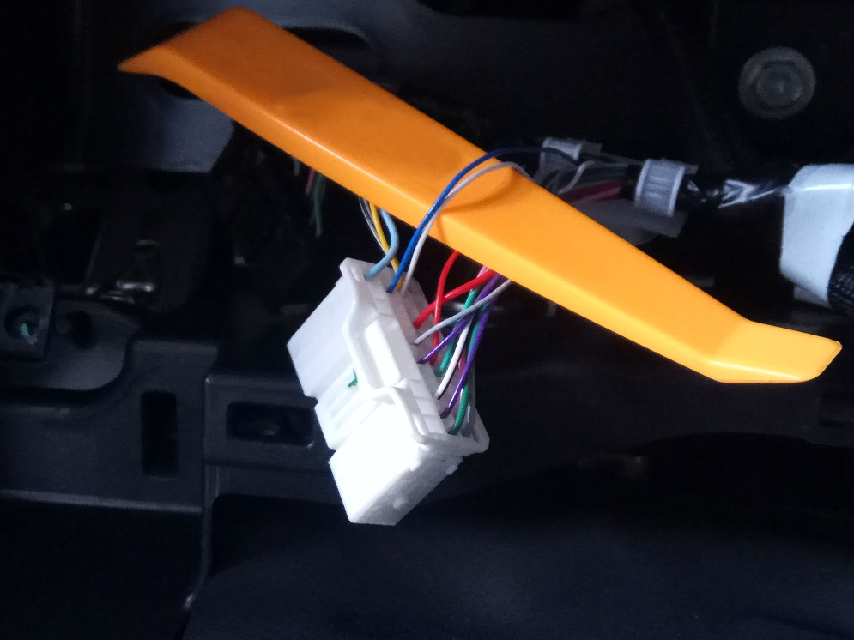
Optional connection
Central door locking | Violet (unlock)  Blue/Yellow(lock) | Info not available at the moment
Engine Block  Max 10A | Green wires: | STARTER (only for manual transmission): Cut the GREEN wire of the 2 pins BLACK connector, directly linked to the friction pedal.  STARTER: Cut the BROWN wire pos.14 of the 27 pins WHITE connector, linked to the BLACK central unit fixed vertically, behind the glove compartment.  ENGINE: Cut the BLUE wire, linked to the fuse “EFI NO.2”, into the fuse box, into the engine compartment on the driver side.
Modules Command  Max 100 mA | Brown/Black: | The COMFORT function is obtained through the original remote control.

